
CONCEPCIÓN ROMERA SÁEZ
Engineer in Geodesy and Cartography
Department of National Atlas and Thematic Cartography
National Geographic Institute
General Ibáñez Ibero,3
28003 Madrid (Spain)
+ 034 915979695; + 034915979765 (fax)
cromera@fomento.es
- Working in the National Geographic Institute of Spain, in the Thematic Cartography and National Atlas department since 2002. Main tasks: performing, updating and production of the National Atlas of Spain in its diverse products; digital (cartographic viewer , electronic atlases, etc) and non-digital products ( books, poster, wall map)
- Member of the Commission of Cartography and Children (CCC) of the International Cartographic Association (ICA)

- Member of the Spanish Society for Cartography, Photogrammetry and Remote Sensing.
- Presence at Cartographic International and National Conferences

IGN/CNIG CORPORATIVE CARTOGRAPHIC VISUALIZER AS WEB CLIENT OF OGC GEOSPATIAL WEB SERVICES
C. Romera and A. del Campo
Thematic Cartography and National Atlas department
National Geographic Institute (Spain)
cromera@fomento.es; adelcampo@fomento.es
P. Abad, J. A. Alonso and A. F. Rodriguez
Geomatic department
National Geographic Institute (Spain)
pabad@fomento.es; jaajimenez@fomento.es; afrodriguez@fomento.es

ABSTRACT

The IGN/CNIG corporative cartographic visualizer and the configuration application are presented here.
The visualizer shows, in an interactive manner, topographic and qualitative thematic mapping, digital terrain models, ortophotos and ortoimages, and it also allows us to consult the associated alphanumeric databases and multimedia resources. The visualization can be made simultaneously in three windows in 2D, 2,5D and flight simulation, with the option of views synchronization. Two types of users are distinguished; the corporative user and the user of a Spatial Data Infrastructure (SDI).
For the corporative user, the information shown by the visualizer, defined in the configuration application, can reside either in its local machine, organization LAN servers or being provided through Open Geospatial Consortium (OGC) Web services: Web Map Service (WMS), Web Coverage Service (WCS), and Web Feature Service as Gazetteer Service (WFS).
For a Spatial Data Infrastructure (SDI) user, the information shown by the visualizer will only be provided through any WMS, using in the perspective view and flight simulation the information of a Digital Terrain Model published by means of a WCS. In this way, the visualizer has an option of specifying any WMS and WCS available in SDI nodes, so that the user can select the information of these services that wishes to jointly visualize. It is available a transformation in real time between different geodetic reference systems and map projections in order to make possible that joint visualization from different sources.
The application allows the access, at least, to the gazetteer service profile (WFS-MNE) implemented in the Spanish SDI geoportal (in Spanish, IDEE).
The visualizer allows asking, by means of the GetFeatureInfo function of the WMS specification, for the attributes associated with geographic information provided by that specific service.
The client application of the visualizer consists of a plug-in, for each Web browser supported, that the user will be able to download from the IDEE geoportal (www.idee.es). Also, new versions of that plug-in will be automatically download and installed previous user consent. Among these functionalities, those derived from the use of the digital terrain model are emphasized, allowing to calculate new layers such as contours, shaded relief, etc.
The application configuration allows setting up customized visualizers by means of the modification of four variables: layers of spatial information, alphanumeric databases and multimedia resources, functionalities and graphic design.

1. BACKGROUND

In 2006, the National Geographic Institute (IGN) and the National Centre of Geographic Information (CNIG) of Spain launched a group of corporative applications for cartographic visualization. These applications accessed local data or network data in the local area and thought they were always executed locally, could have local or network installation.
In 2007, this application can already access data sources provided by Geospatial Web services; either proprietary or standard services as it is necessary in the case of the SDIs, those that fulfil standard specifications of the Open Geospatial Consortium (OGC): Web Map Service (WMS), Web Coverage Service (WCS) and Web Feature Service (Spanish Spatial Data Infrastructure profile).

2. GENERAL TECHNICAL DESCRIPTION

The set consists of three applications: a visualizer, an administration application and an application to configure the geographical information to be included in it.
The development of the visualizer has been led by the GIS department and Thematic Cartography and National Atlas department of the Deputy Directorate for Geographical Information Applications of the National Geographical Institute of Spain. The visualizer has been developed in Visual C++ and server/client environment.

2.1. Visualizer

The main application is the cartographic visualizer itself for vector and raster data, digital terrain models, ortophotos and ortoimages. The visualization can be made simultaneously in several windows in two dimensions (2D), perspective (2,5D) and flight simulation (3D).

It can show raster and vector information, in an encrypted format, in native formats, standard formats or characteristic formats of other extended use applications (.SHP, .DGN, .TIFF, .ECW, etc.).

The visualizer is designed to work with a huge amount of data. This is possible because of the way the core manages the information, vector data access to retrieve only slightly more information than needed for display and raster uses pyramidal technique.

New layers can be calculated in real time from the digital terrain model, with different algorithms and parameters: contours, hypsometry, relief shaded, slopes, shown and hidden areas or to carry out other types of calculations (profile, geometric distances, horizontal distances, maximum slopes, heights, etc.). The generated layers and the algorithms and parameters can be saved in the project global configuration or in each concrete tool configuration.
The incorporation of vector information offers important possibilities: to calculate the profile and length along the geometry of the selected entity, to cross it, etc. The user can also create new punctual, lineal or superficial vector entities.
The user knows at every moment the UTM or geographical coordinates of the cursor and can move it to a point of well-known coordinates.
Flight paths can be defined in 2D or 3D and aircraft or camera motions in each point of the flightpath (except roll aircraft and yaw camera motions) as well as in 2D or 3D. All these parameters can be saved to disk as can video files with each flight path generated. It also incorporates a powerful searcher engine on alphanumeric databases and associated multimedia resources. Furthermore, it allows us to import and export GPS routes.
Two interface types have been developed, one dedicated to professional users and another to non specialized users.
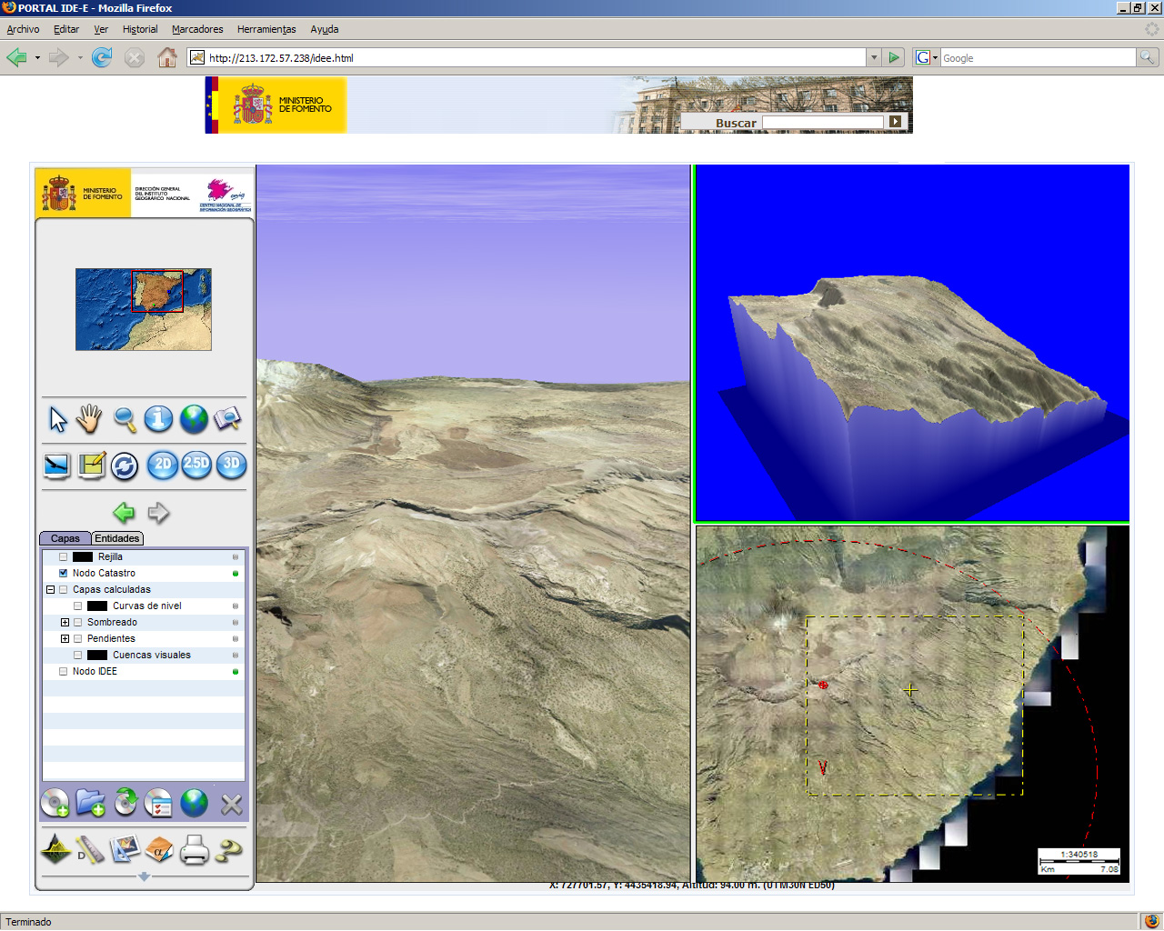

Fig. 1. - Interface with lateral menu bar of functionalities. This interface facilitates the work to less familiarized user as the basic functionality is visible

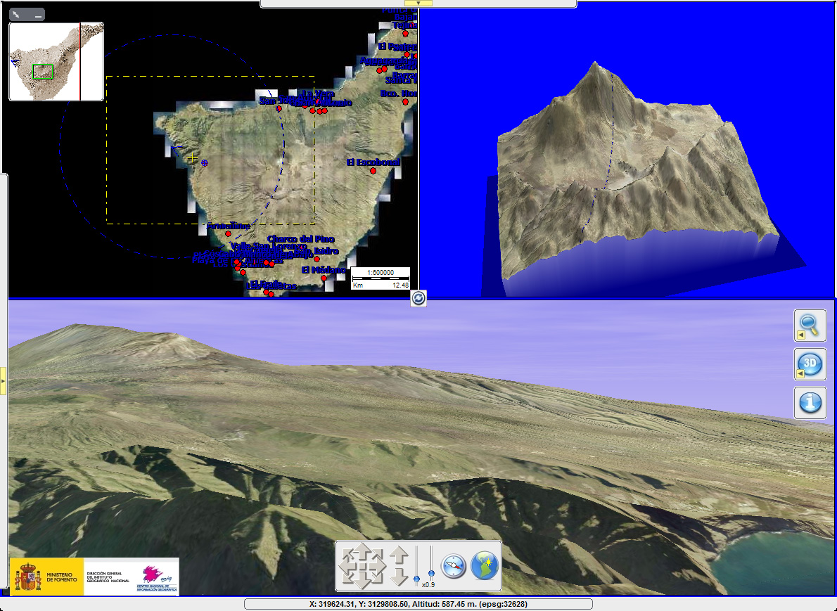

Fig. 2. - Interface with hidden bars and drop down menu. This interface is dedicated to a professional user in the environment of corporative visualizer.

The visualizer also allows the user to load his own layers of WMS different but only for visualization and while the session lasts. Also, in the near future we aim to integrate the OGC standard Web Map Context to maintain the consistency among sessions in the connection to Web Geospatial OGC standard services.

The visualizer can work in a local way (as a heavy client), downloaded through Internet as autonomous desk clients (stand-alone) or downloaded as plug-in for Internet Explorer and Mozilla Firefox web browsers. The plug-in can also be inserted in a specific area (frame) within a web page that includes other contents.

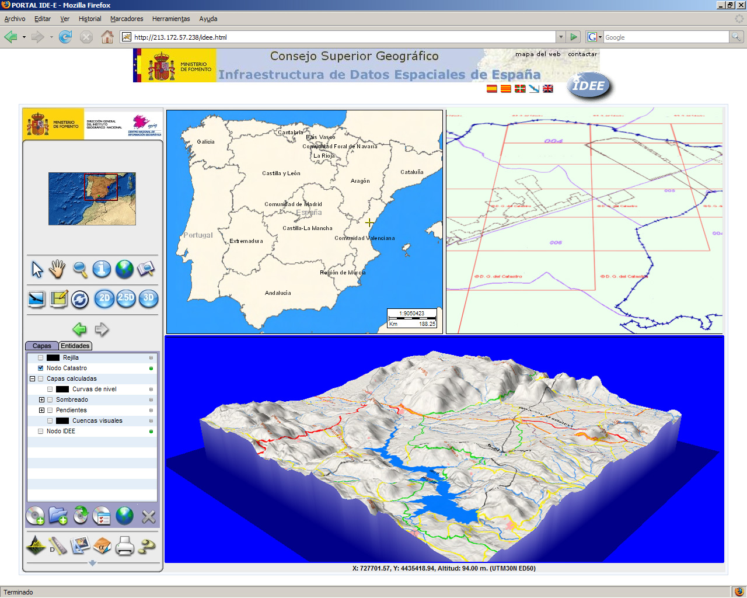

Fig. 3. - Specific visualizer generated for Spatial Data Infrastructure of Spain (IDEE)

The figure 3 shows an image of a specific visualizer generated for Spatial Data Infrastructure of Spain (IDEE) integrated in geoportal (www.idee.es). For the information shown in perspective, the visualizer is accessing the Digital Terrain Model and the cartography provided respectively by the WCS and WMS services of the IDEE node. In another window, it is flying over the information provided by a WMS service of the node of the General Address of the Cadastre. The information of the different services could overlay in the same window.

Light and heavy clients check for new online versions; if there's a new one, it is downloaded and installed automatically or by asking the user for permission (depending on download politics that the strategy defined). This allows users more control over versions installed.

The architecture (desktop client/ plug-in type client) is represented in the enclosed figures.

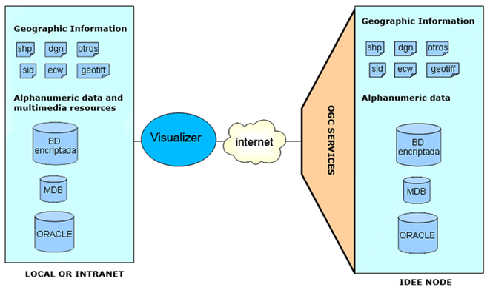

Fig. 4. – Desktop client architecture

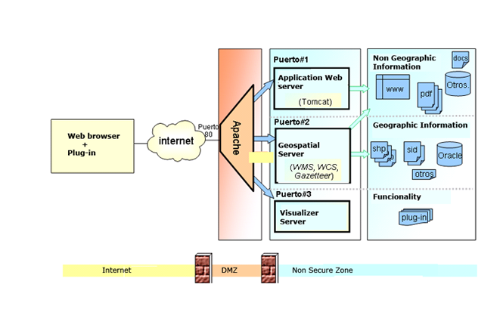

Fig. 5. –Plug-in client architecture.

2.2. Administration application

Personalized visualizers can be created not only by selecting contents (layers of geographical information, alphanumeric database and associated multimedia resources) and functionalities, but also by choosing the look and feel of the interface (aspect). The visualizer is generated by means of a “save as” function type.
The functionality that allows the users to be connected to geospatial web services defined by themselves can be included, although this possibility can be restricted from the load application.

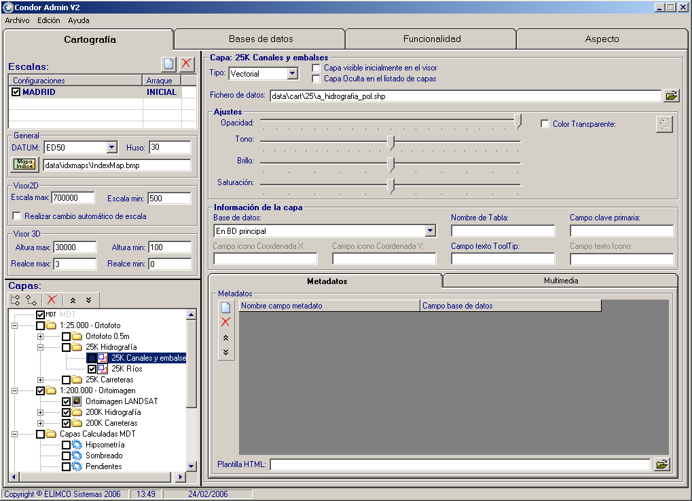

Fig. 6. - Administration application

2.3. Making geographical information ready for use

The third application allows us to prepare the geographical information and if it is desired to transform it into the own encrypted vector or raster formats and therefore to increase the speed of visualization.

3. FUTURE DEVELOPMENTS

Some of the future developments that we are studying:
- Implementation of catalogue service that allows to find metadata
- Connection to Web Feature Services (WFS) as data source.
- Installation of the Web Map Context service (WMC)
- Operation in any client platform (Windows, Mac, Linux, UNIX, etc.)
- Creation of CD/DVD visualizers that pack functionality, contents and aspect for different browsers.
- Authentication support bearing in mind that there will be as many visualizers as users want. This allows to generate personalized visualizers by corporative users in terms of functionality, contents and aspect.
- Development of the automated procedure and code to insert the visualizer in other applications or web pages.
- Authentication support fit to web environment.
- Update of contents via Web in products sold as CD/DVD through connection to the payment platform of the National Centre of Geographical Information.
- Creation of look and feel libraries (colour bars, pop ups, etc.), 2D symbols libraries and 3D models for different cartographic series. The user will be able to change the legend symbols from imported library symbols that have been created in other applications such as 3D Studio, Illustrator, Freehand, etc.
- In the local environment, users will have forms that allow them to add, modify or eliminate information (registries, fields, values) in the application databases This added information will have to be differentiated clearly from that originally provided in CD or DVD, because these actions will act in a new database without altering the original one.
- In any of the three visualization ways (plane, perspective and flight simulation), geographical positions and vector geographical entities in the first case will be associated to original or new registries of databases, introducing the coordinates with the keyboard or graphically with mouse interaction on the reference cartography aided by rules or grids and, in the second case, selecting the corresponding geographical entity.

4. CONCLUSIONS

This set of corporative applications allows us to generate specific visualizers that integrate geographic information, alphanumeric and multimedia databases linked to entities or geographic locations, functionalities and aspect, distributed via CD/DVD or Web, adapted to user requirements and the aim (promotion, value added with the sale of geographic information, diffusion of general or thematic cartographic series, visualization of information hosted in Spanish Spatial Data Infrastructure (IDEE) nodes, visualization of Intranet /Internet corporative geographic information)

A classification of possible uses based on the architecture (independent client or plug-in) of the visualizer and the location of data sources can be seen in the following table.
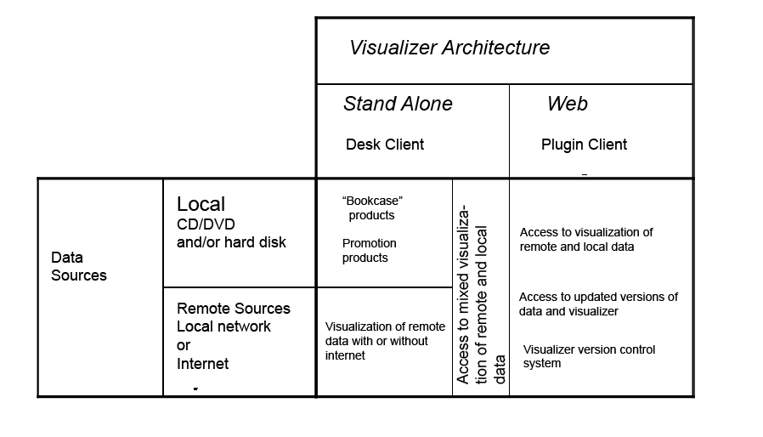
Fig. 7. - Possible application

